-----------------------------------------------------------------------------------------
Tilt Module
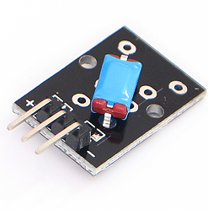
Features Working voltage: 3.3V~5V; digital switch output (0 & 1); High sensitivity

Tilt module can connect UNO R3 PIN13, make tilt remind test.
Pin 13’s LED，use tilt module connect Pin 3. When tilt module test there is button, led can be bright.

Code：
int Led=13;//定义LED 接口
int buttonpin=3; //定义倾斜开关传感器接口
int val;//定义数字变量val
void setup()
{
pinMode(Led,OUTPUT);//定义LED 为输出接口
pinMode(buttonpin,INPUT);//定义倾斜开关传感器为输出接口
}
void loop()
{
val=digitalRead(buttonpin);//将数字接口3的值读取赋给val
if(val==HIGH)//当倾斜开关传感器检测有信号时，LED 闪烁
{
digitalWrite(Led,HIGH);
}
else
{
digitalWrite(Led,LOW);
}
}

